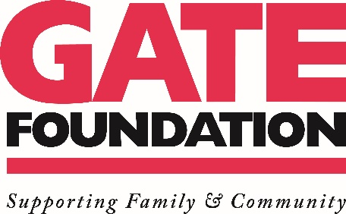

Press Release Contact: Kathy Brady
For Immediate Release Phone: 904.732.2339

GATE Marks 60th Anniversary with $60,000 Donation to Boys & Girls Club of Northeast Florida

GATE Vendors Contribute $60,000 Matching Funds for Total of $120,000 Donation

JACKSONVILLE, FLA., October 21, 2020– GATE Petroleum Company is celebrating its 60th anniversary this fall, marking the occasion with a $60,000 to the Boys & Girls Club of Northeast Florida from The GATE Foundation.

“GATE is proud to be a Jacksonville company,” said John Peyton, president of GATE Petroleum Company. “We value family and a strong, connected community. Supporting the Boys & Girls Club of Northeast Florida aligns with those values and is the perfect way to honor our customers and Jacksonville, the city we’ve called home for the past six decades.”

The GATE Foundation also used the 60th anniversary donation as an opportunity to raise matching funds from its vendors and business partners. The Foundation typically hosts its annual charity golf tournament in the fall, where supporters raise money for a selected charity. However, COVID-19 restrictions put a halt to the 2020 event.

“While it was disappointing to cancel this year’s golf tournament, we are grateful that we could pivot and see this generous show of support from our partners,” said Kathy Brady, executive director of The GATE Foundation. “We are honored to celebrate GATE’s 60th anniversary in business by supporting the Boys & Girls Club and support their efforts to positively impact young people all across Jacksonville.”

The vision of the Boys & Girl Club is to assure that every child graduates on time with a plan for their future, leads a healthy lifestyle and demonstrates good character and leadership. Today, the organization provides fun after school experiences and educational programming to more than 8,000 members across 36 locations throughout Duval, St. Johns and Alachua counties.

“We are overwhelmed with appreciation for the generosity and support of our long-term partner The GATE Foundation,” said Paul Martinez, CEO and president of Boys & Girls Clubs of Northeast Florida. “These gifts represent an investment in the lives of youth we serve, allowing them to create great futures for themselves and their community. We are honored to be a partner with GATE.”

-- more --

About The GATE Foundation:
The GATE Foundation, the philanthropic arm of Jacksonville, Florida-based GATE Petroleum Company, supports efforts and services that nurture and protect the well-being of families and the communities where it operates. GATE Petroleum, one of the largest privately held companies in Florida, was founded in 1960 by Herbert Hill Peyton. Today, GATE’s diversified operations include retail, construction materials, hospitality and commercial land development sectors. The company’s convenience stores are located throughout Florida, Georgia, North Carolina and South Carolina. GATE also operates eight precast concrete plants, a host of real estate ventures, a hospitality division including an AAA Five Diamond resort, as well as fuel and fleet services.

For more information on The GATE Foundation, visit http://myGATEstore.com/Community or call (904) 737-7220.

###

